## ancillary_files table

## Fields

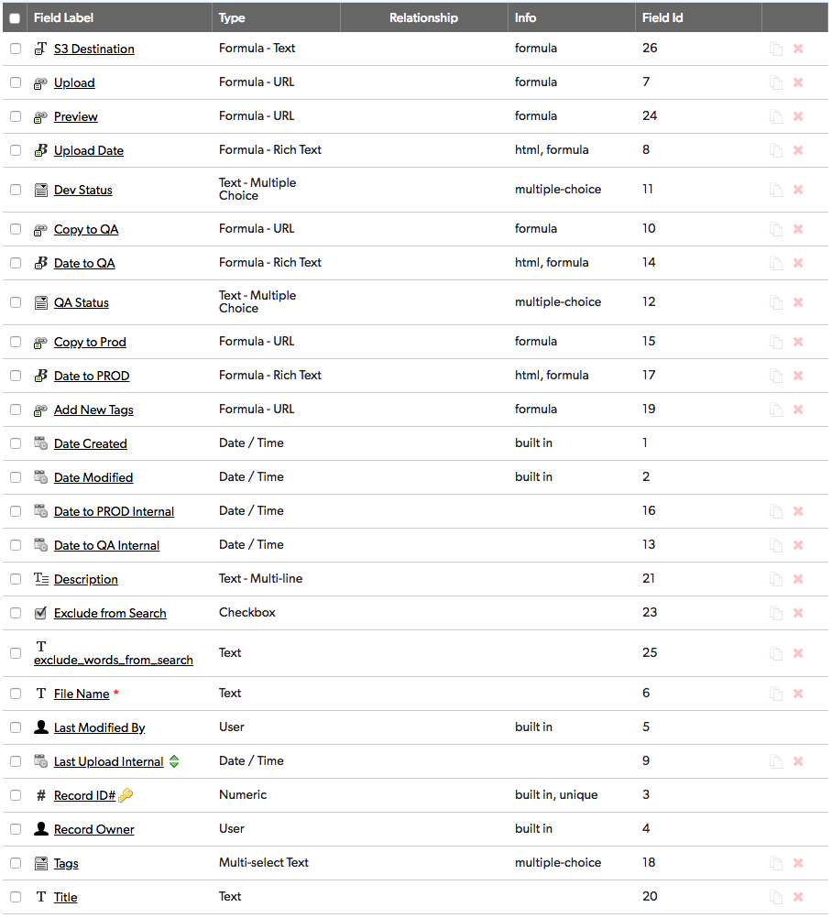

## Field settings

Note: Built-in fields use the default settings

S3 Destination 3

Upload 3

Preview 3

Upload Date 3

Dev Status 4

Copy to QA 4

Date to QA 4

QA Status 4

Copy to Prod 4

Date to PROD 4

Add New Tags 4

Date to PROD Internal 5

Date to QA Internal 5

Description 5

Exclude from Search 5

exclude_words_from_search 5

File Name 5

Last Upload Internal 5

Tags 6

Title 6

# S3 Destination

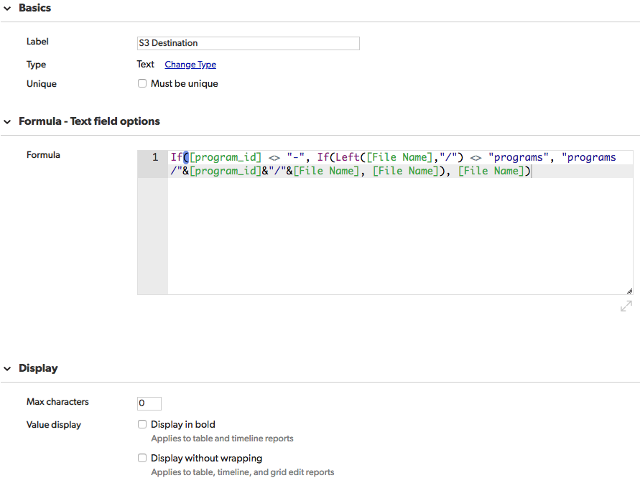

If([program_id] <> "-", If(Left([File Name],"/") <> "programs", "programs/"&[program_id]&"/"&[File Name], [File Name]), [File Name])

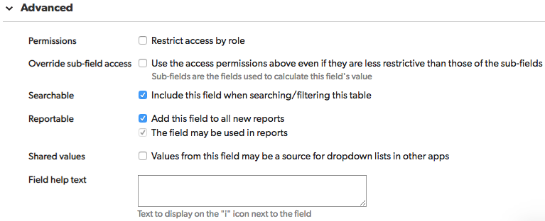

# Upload

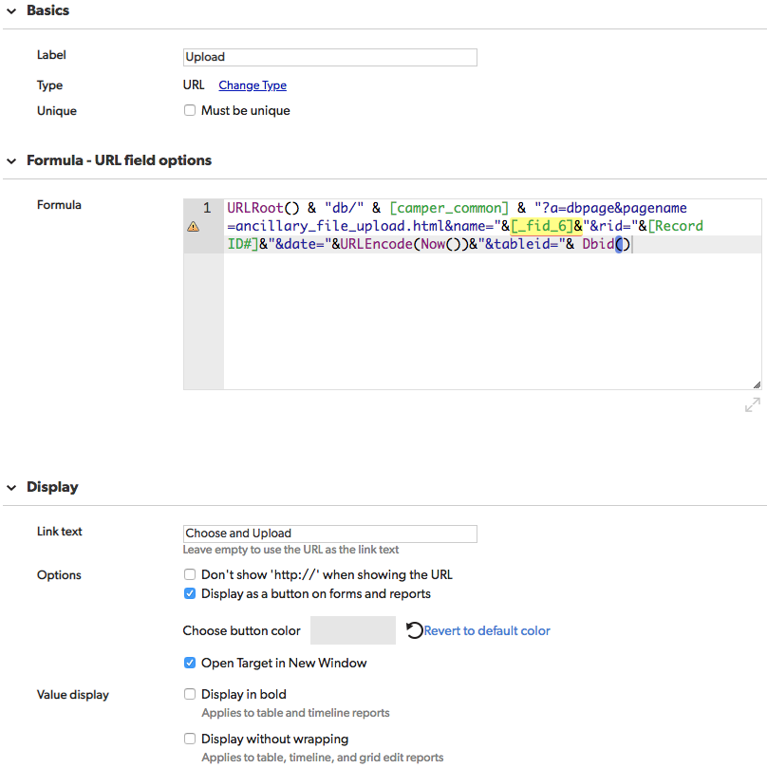

URLRoot() & "db/" & [camper_common] & "?a=dbpage&pagename=ancillary_file_upload.html&name="&[_fid_6]&"&rid="&[Record ID#]&"&date="&URLEncode(Now())&"&tableid="& Dbid()

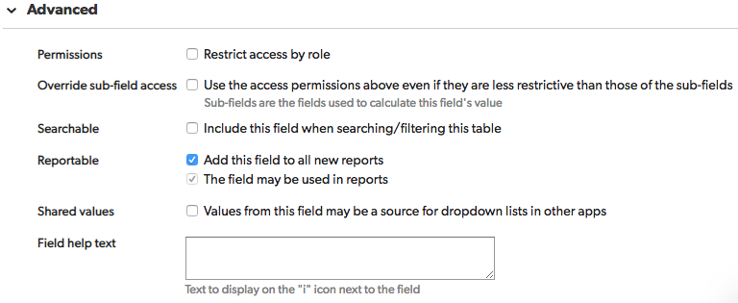

# Preview

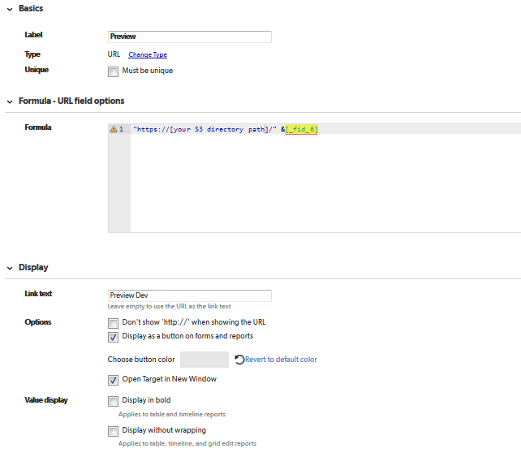

"https://[your S3 directory]/" &[_fid_6]

UPDATE THIS WITH YOUR OWN S3 DIRECTORY PATH

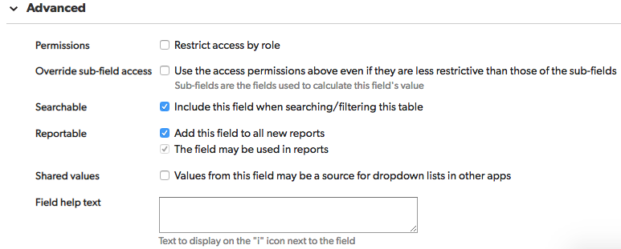

# Upload Date

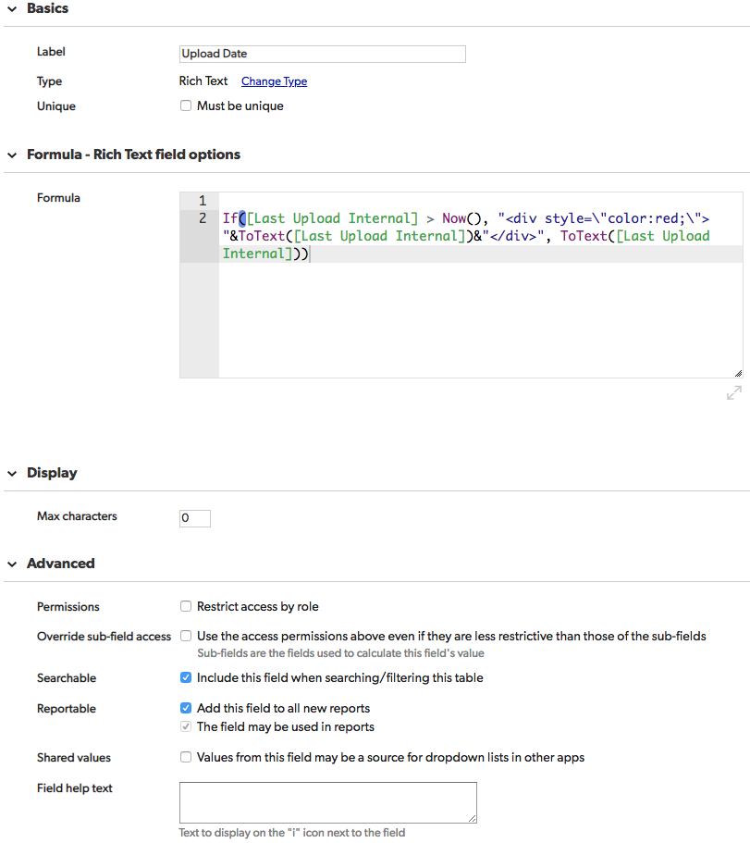

If([Last Upload Internal] > Now(), "<div style=\"color:red;\"> "&ToText([Last Upload Internal])&"</div>", ToText([Last Upload Internal]))

# Dev Status

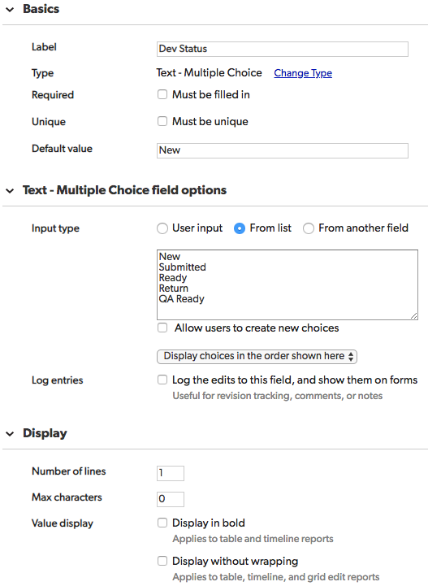

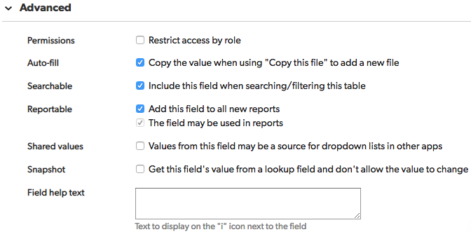

# Copy to QA

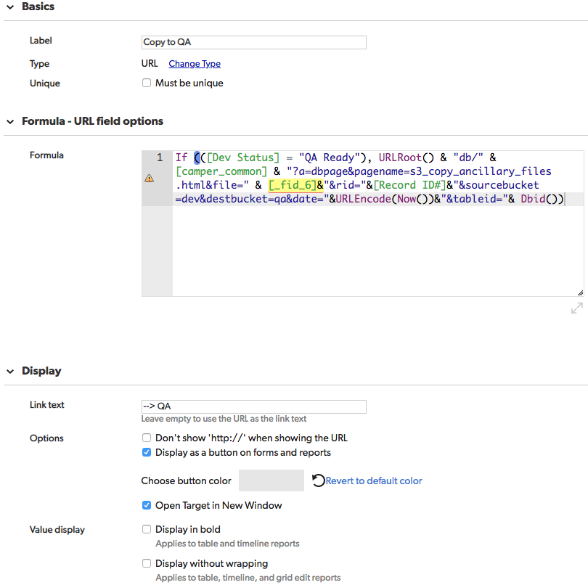

If (([Dev Status] = "QA Ready"), URLRoot() & "db/" & [camper_common] & "?a=dbpage&pagename=s3_copy_ancillary_files.html&file=" & [_fid_6]&"&rid="&[Record ID#]&"&sourcebucket=dev&destbucket=qa&date="&URLEncode(Now())&"&tableid="& Dbid())

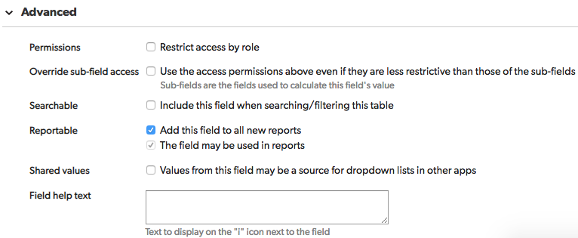

# Date to QA

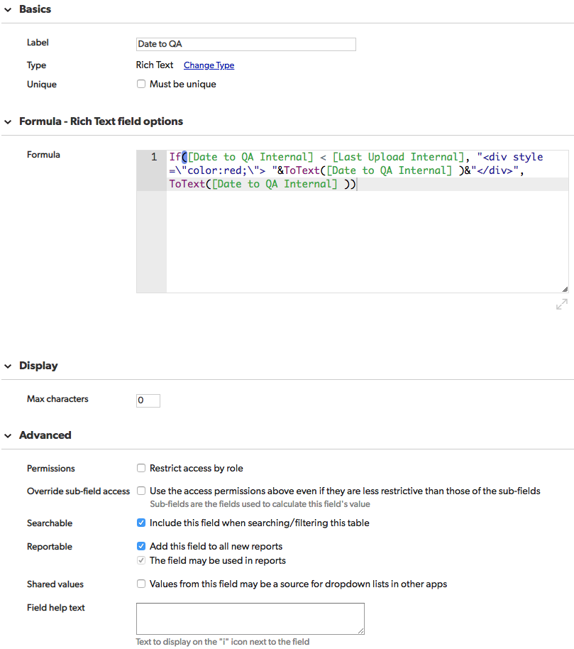

If([Date to QA Internal] < [Last Upload Internal], "<div style=\"color:red;\"> "&ToText([Date to QA Internal] )&"</div>", ToText([Date to QA Internal] ))

# QA Status

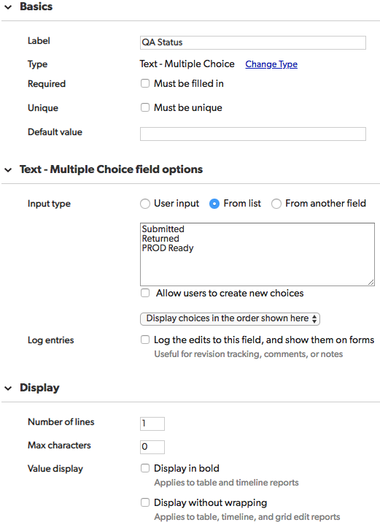

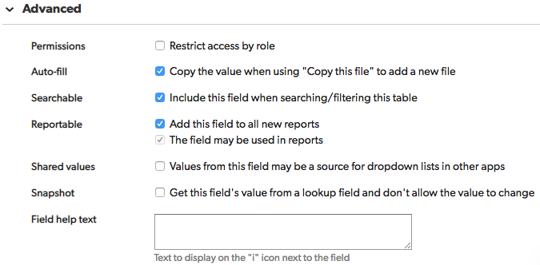

# Copy to Prod

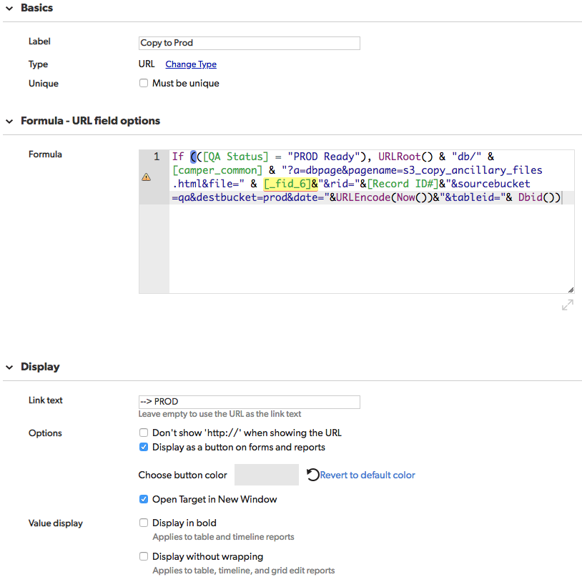

If (([QA Status] = "PROD Ready"), URLRoot() & "db/" & [camper_common] & "?a=dbpage&pagename=s3_copy_ancillary_files.html&file=" & [_fid_6]&"&rid="&[Record ID#]&"&sourcebucket=qa&destbucket=prod&date="&URLEncode(Now())&"&tableid="& Dbid())

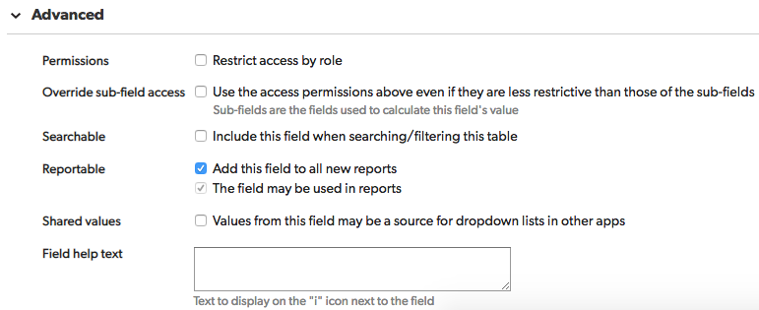

# Date to PROD

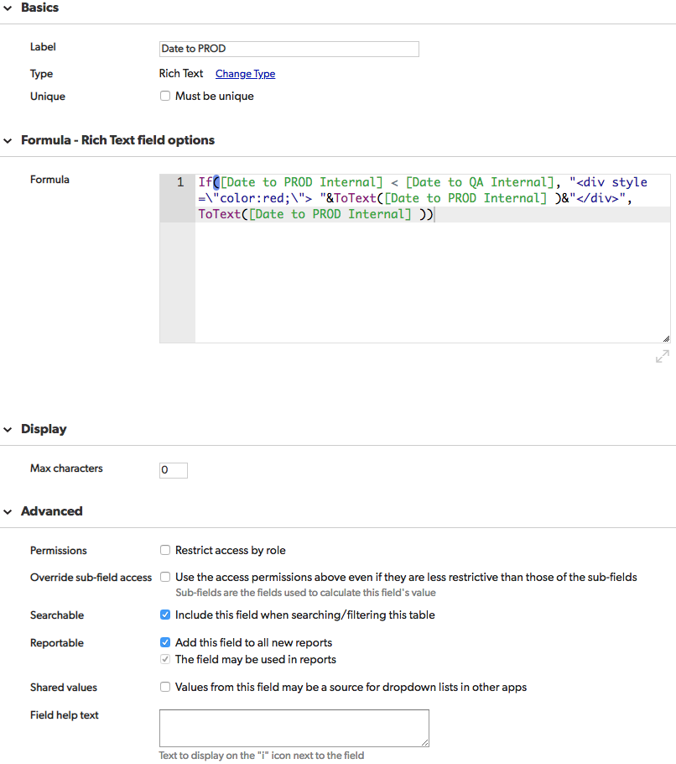

If([Date to PROD Internal] < [Date to QA Internal], "<div style=\"color:red;\"> "&ToText([Date to PROD Internal] )&"</div>", ToText([Date to PROD Internal] ))

# Add New Tags

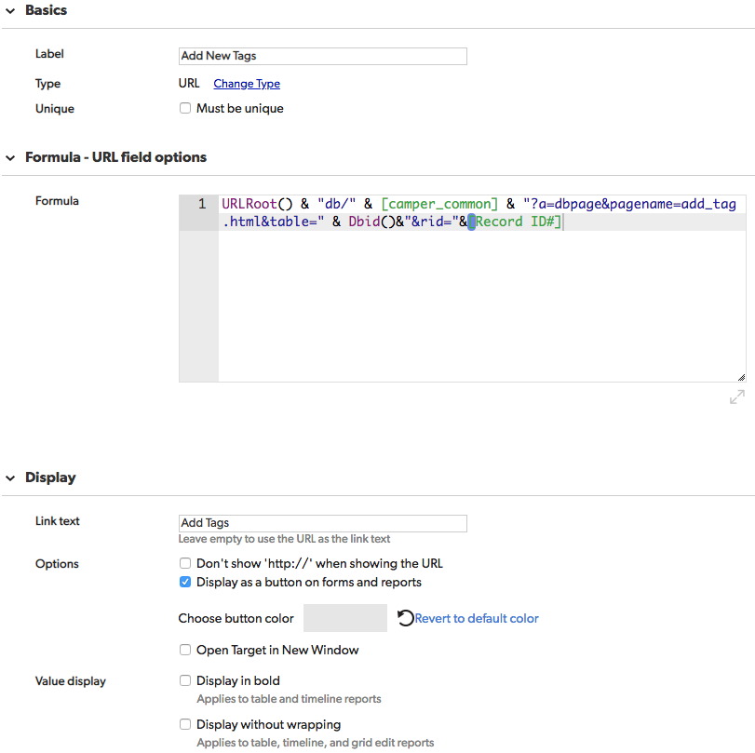

URLRoot() & "db/" & [camper_common] & "?a=dbpage&pagename=add_tag.html&table=" & Dbid()&"&rid="&[Record ID#]

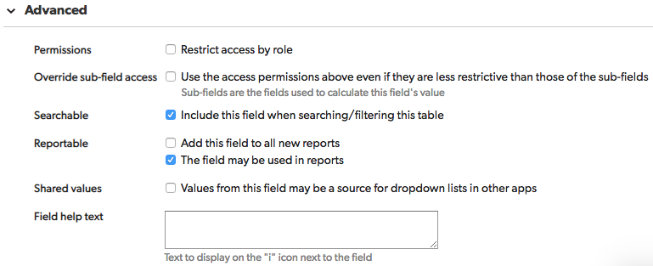

# Date to PROD Internal

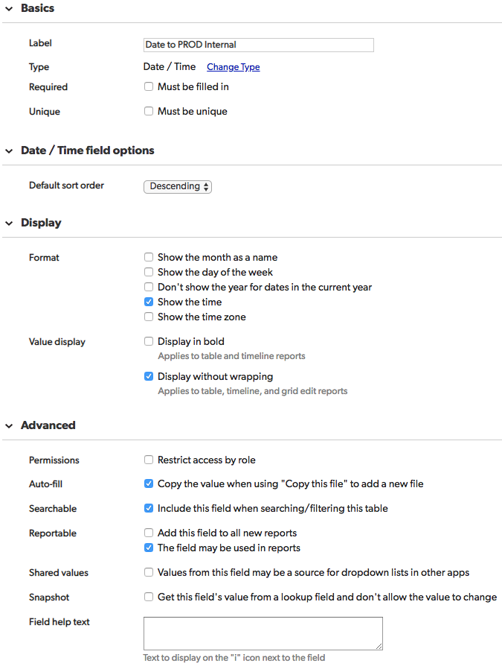

# Date to QA Internal

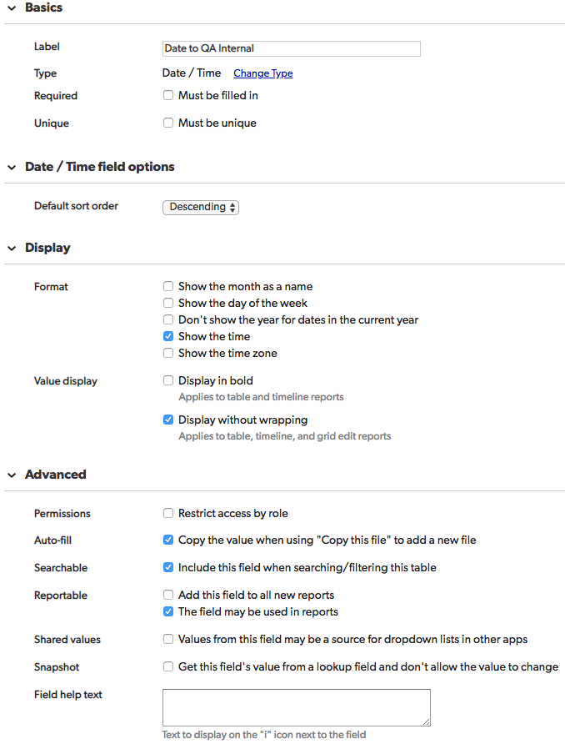

# Description

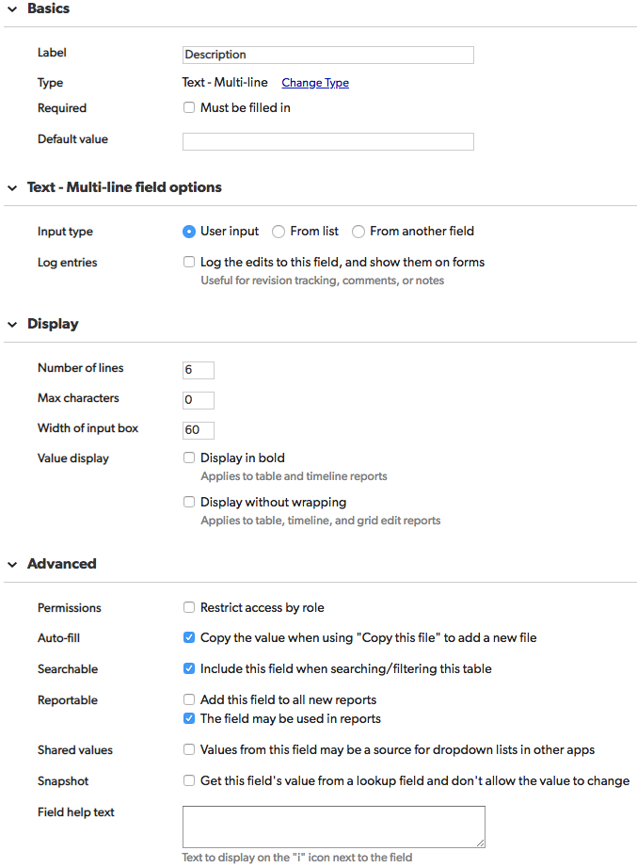

# Exclude from Search

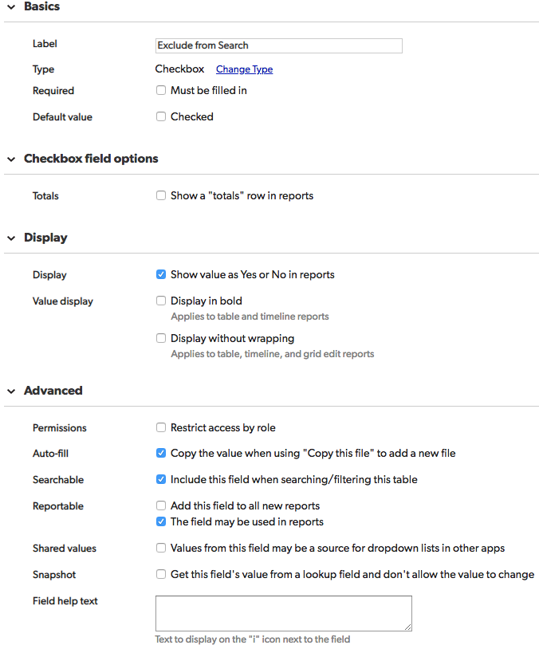

# exclude_words_from_search

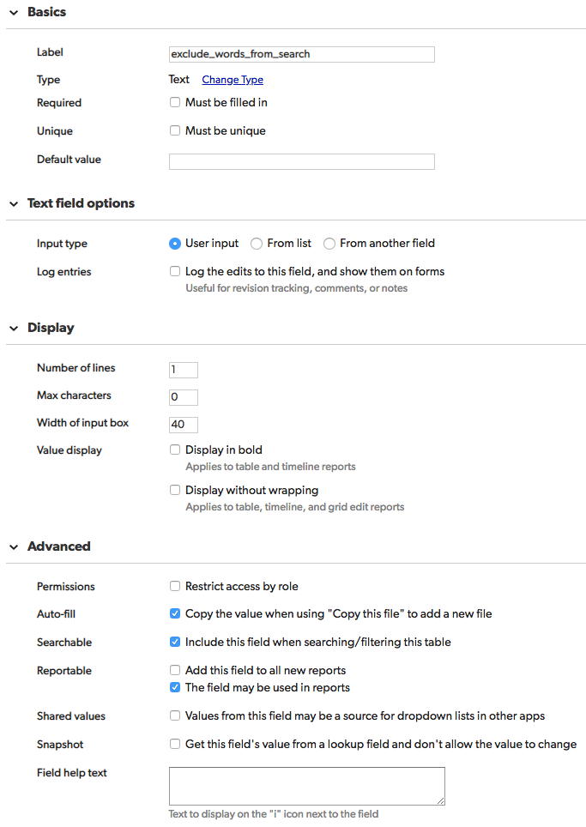

# File Name

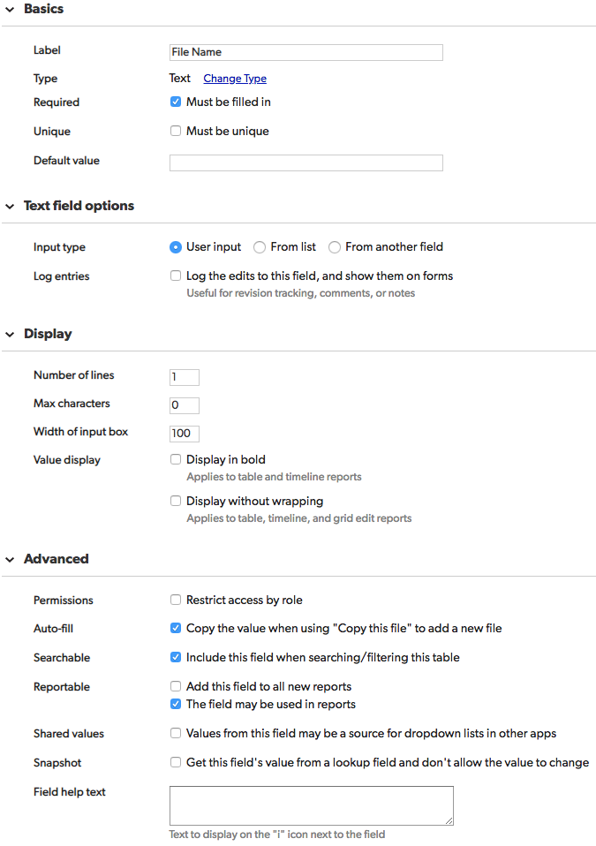

# Last Upload Internal

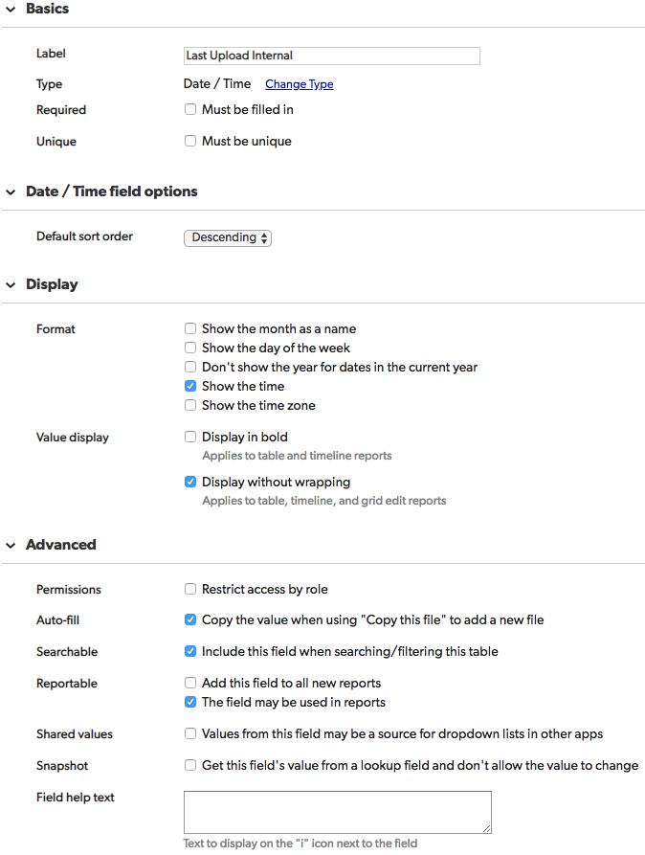

# Tags

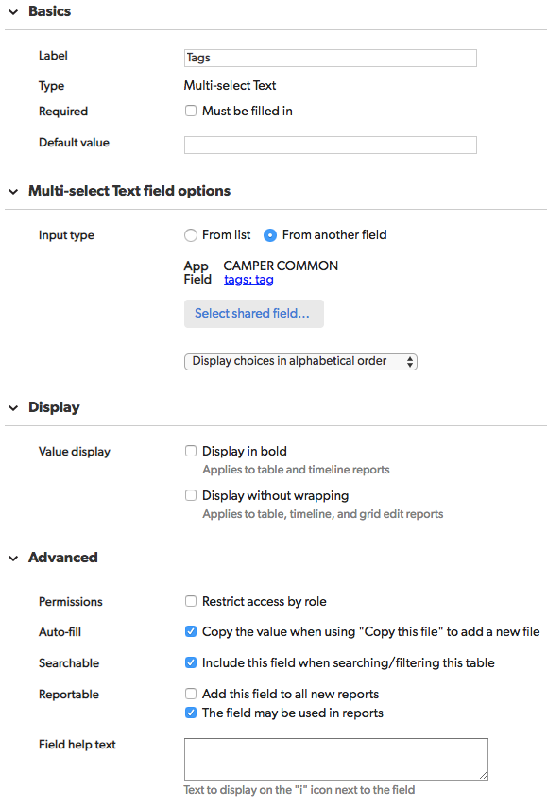

# Title

